Inland Revenue

Business Transformation Programme
Initiative Charter

<<insert Initiative name>>

Business Sponsor:

Product Owner:

Initiative Lead:

Prepared by:

Date:

Document Signoff
Review Area | Name | Signature | Date

Contents
1 Initiative reference 3
2 Initiative leadership 3
3 Initiative description 3
4 Legislative requirement 3
5 Key reference documents 3
6 Delivery considerations 3
7 Key assumptions 4
8 Key delivery dependencies 4
9 Key risks apparent at the start of the initiative 4
10 Issues apparent at the start of the initiative. 4
11 Initiative scope reference 4
12 Initiative delivery approach 5
13 Initiative schedule 5
14 Contributing team checklist 7
15 Initiative high level requirement decomposition 12
16 Summary of initiative finances [$M]– mm/yyyy 13
17 Supporting Information 14

When you have completed this Charter please store it in the BT Scope library on BT SharePoint. Then link/attach it to the Scope item ticket in JIRA and the PCR doc (if applicabe)

Initiative reference
Initiative Name | <<Name / Title >>
Jira ID: #### | Date Approved: mm/dd/yy | Due Date: mm/dd/yy
<<Please request the Initiative Name and ID# from Release Delivery Support>>

Initiative leadership
Business Sponsor
Product Owner
Initiative Lead

Initiative description
Initiative background
Implementation of a new ….
Provide here a brief overview of the initiative background, this could be carried forward from the “Lean Business Case” or similar.
Initiative objectives & outcomes
Provide here the objectives & listed outcomes of the initiative, this could be carried forward from the “Lean Business Case” or similar.

Legislative requirement
This initiative delivers a legislative requirement (note Policy Team impact/requirement):
☐ Yes
☐ No

Key reference documents
Document Name | Description | Location | Contact

<<Please Note: Jira #’s/tickets may be created after this document is prepared – initially, the summary and owner will suffice with the formal JIRA references updated once these are available.>>

Delivery considerations
Considerations
Provide here any delivery considerations – e.g. the impact on the business operations or customers if the work is not completed. A holiday or event that may influence the deployment date. Availability of key resources that could constrain a schedule, etc. These might end up being dependencies which are formally tracked via JIRA or influence commencement, etc.

Key assumptions
Assumptions
Provide here any important assumptions that have been made preparing the implementation charter

Key delivery dependencies
JIRA # | Description | Owner
 | << Jira reference can be completed once available>>

Key risks apparent at the start of the initiative
JIRA # | Summary | Owner
 | There is a risk that....

Issues apparent at the start of the initiative.
JIRA # | Summary | Owner

Initiative scope reference
JIRA SCP # | Title / Description
<<Primary>>
<<Sub-Item/s>>
<<Include above the primary scope number and the sub-items as relevant.>>

Initiative delivery approach
Delivery will be modelled on:
☐ Major Release - Jellybean / BTM Led (e.g., BT Release 4)
☐ Medium Size Release - Product Owner Led (e.g., Annual Change)
☐ Minor Change – Product Owner Led (Optimisation)
☐ Minor Change - Production Support Led (e.g., Loss Carry Back Scheme)

Implementation plan
Approach, timeline, key milestones and dates, and the rationale for these dates

Initiative schedule
<<At this stage in the detailing of the initiative, the schedule is included to provide the book end dates, key activities, milestones and interdependencies, format is of lesser importance. A template is available here HYPERLINK>>
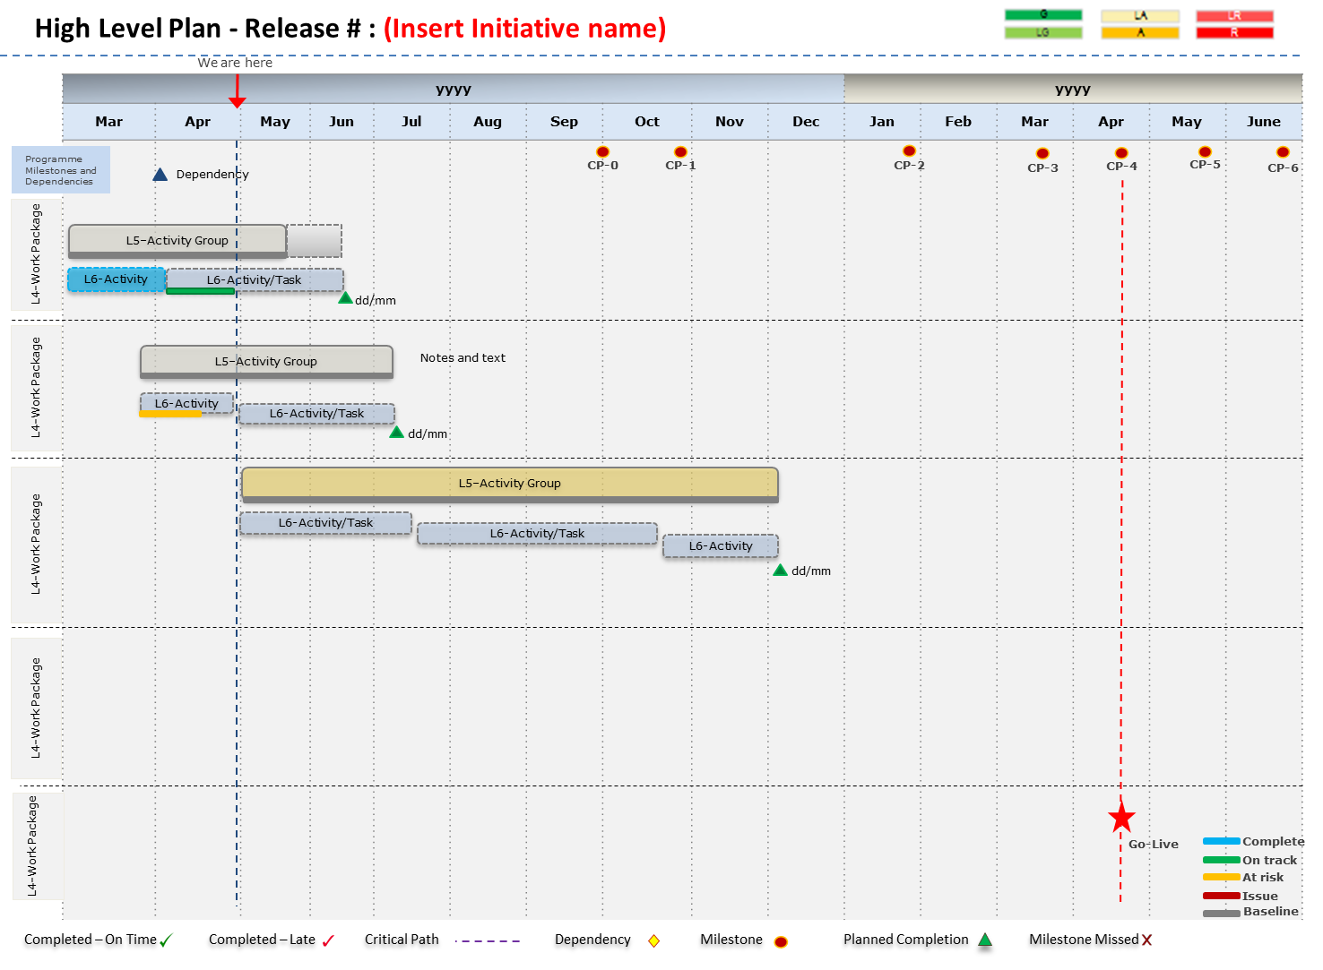
Please note: The work breakdown should be kept at a high level and limited to key activities, deliverables, and milestones. This may mean may that one has to wait for the Business Function Definition (BFD) plan to be completed or early planning prepared by the delivery lead.

Work Breakdown (WBS) | Start | Finish | Description
<<Key Milestone/s>> | dd/mm | dd/mm
<<Key Activities>> | dd/mm | dd/mm
<<Key Deliverable/s>> | dd/mm | dd/mm

Contributing team checklist
(Current list of teams delivering services to the outcome. To help with effort estimation, if there is work to do, then estimate using a T-Shirt sizing method. See the Appendix for the table of estimation)
Team | Required in this initiative  Yes/No | Typical Activities / Services Provided | Team Contact | Team member(s) assigned to initiative (SPC bolded) | Planned work/key activities for this initiative  (incl. T-Shirt effort estimate)
INITATIVE LEAD |  | - Initiation of the initiative including setting up the tracking controls in the delivery systems (Jira Initiative Label, Teams site, FCR project)  - Planning, Scheduling & Controlling Delivery of the outcome  - Status Reporting  - Securing Resources (Resource plan)  - Risk, Issue, Dependency Management / Controls  - Readiness Assessments  - Exit / Closure reporting  - Quality Management | <<tbc>>
BUSINESS UNIT RESPONSIBILITIES |  | - Organisational Changes  - Business Resourcing  - Tactical Planning Impact assessment  - Data cleansing and enrichment  - Customer engagement as directed by Communications team  - Business Readiness Assessment | <Sponsor>  <Business Lead>
EVENTS TEAM |  | - Planning scheduling, executing, and controlling business as usual events.
BUSINESS UNIT RESPONSIBILITIES |  | - Organisational Design Changes  - Business Resourcing  - Tactical Planning Impact assessment  - Data cleansing and enrichment  - Customer engagement as directed by Communications team  - Business Readiness Assessment  - Business Deployment Support (e.g., Start-up/Shut Down processes, Outage Planning and Sponsorship) | <<Business Lead>>
POLICY |  | - Policy development and taxpayer impact  - Government & stakeholder priority  - MoR and other Govt Minister engagement
PRODUCT OWNERSHIP |  | - Product Strategy development and maintenance  - Key internal senior stakeholder management for product owner led initiatives.  - BFD Approval (where applicable per the approach) | <Product Owner>
ACCOUNT MANAGEMENT |  | - Managed Account Engagement  - Customer Readiness Assessment
BUSINESS ARCHITECTURE |  | - Future State Business Function Definitions  - New Initiative Outcome and High-Level Requirement identification.
TECHNICAL ARCHITECTURE |  | - Hardware Sizing  - Infrastructure Architecture Design / Non-Functional Requirements  - Infrastructure Audit / enduring systems list
BUSINESS DESIGN |  | - Business Requirement Definition  - Business Function Definition Approvals  - Letter, Notifications, Correspondence content definition.  - Development Task Verification  - Business System Test preparation and execution  - Test Scope Preparation and presentation to the Test Authority
BUSINESS ANALYSIS |  | - Connecting product strategies and objectives with technical solution  - Contribute to scope definitions, identifying scope gaps & scope creep  - Supporting the design decision & governance process  - Determining and presenting design options  - Identifying crossover boundaries between functional domains, design gaps and conflicting design decisions  - Facilitate resolution of issues / conflicts / interdependencies  - Ensuring that the solution meets legislative requirements, including maintaining business rules traceability  - Supporting testing activities  - Supporting technical and business implementation of the solution
BUSINESS PROCESS DESIGN |  | - Business Process Catalogue  - Business Process Map and Scenario Design  - L4 Business Processes  - Casebook changes  - Rate table changes
START SOLUTION |  | - START Solution Definition  - START Solution Development/Configuration/Verification  - Business System Testing (BST) management  - Scaled Business System Testing (SBS) management  - Functional Security Matrices updates
START DATA CONVERSION |  | - START Conversion Definition  - Data Extraction, Transformation and Load
START REPORTING  (Ensure new reports or changes to existing reports are identified and implemented to satisfy business reporting needs) |  | - Report Definitions  - Report Development  - Report Testing
DIGITAL ECO SYSTEMS (DES)  (Gateway services, Partner Integration) |  | - Design (build pack)  - FAST build / Partner build  - Pre-BST Verification  - Integration BST  - Performance Test  - SBS
DIGITAL CUSTOMER SERVICES (DCS) - (myIR, www) |  | - Define, Build Test  - Customer Validate/Test
CONTENT |  | - Develop/Update content/Publish
HERITAGE |  | - RICEFW Inventory  - Solution design for development and integration  - Test approach and reporting  - Coexistence considerations
IMAGING |  | - Form changes that are imaged, and  - New forms the require imaging  - Image storage
INFORMATION MANAGEMENT
(and for now, placeholder TiMG)
CONTACT CENTRE |  | - Any changes to call flows or voice messaging to support implementation  - Any technical integration changes to SPK2IR or Interaction Manager
ORGANISATION CHANGE MANAGEMENT & TRAINING (incl. Comms & Business Readiness) |  | - Stakeholder Identification and Impact assessment  - Change Analysis  - Communication Approach and Plan (Internal & External)  - Training (Approach, Logistics, Materials, Trainers)  - Develop and publish Help content  - People; Business and Customer Readiness Assessment
TESTING SERVICES |  | - Test approach / Test reporting  - Performance Test Management  - Operational Acceptance Testing
RELEASE DEPLOYMENT |  | - Cutover management for large and medium size releases  - Business ramp down and Ramp Up management
DATA CLEANSING AND ENRICHMENT |  | - Data extraction, migration, mapping and merge designs  - Cleaning attributes and purification overview  - Extraction/migration schedule and plan  - Archiving strategy/ solution
EARLY LIFE SUPPORT / POU WHIRINAKI |  | - Plan and Approach  - Resourcing  - Tools updates
PRODUCTION SUPPORT  (include if Prod Support are delivering changes) |  | - Plan and Approach  - Resourcing  - Tools updates
ANALYTICS (DIP)
TECHNICAL SECURITY |  | - Network and User Security procedures / assessments  - Certification and Accreditation
APPLICATION ACCESS SECURITY |  | - End user access security definition & processes
DECOMMISSIONING AND DATA ARCHIVING |  | - Applications and Infrastructure inventory  - Application shut down  - User access control and cessation  - Data extraction and archiving  - Infrastructure shutdown  - Infrastructure disposal and authorising memos
ENVIRONMENT SERVICES |  | - Hardware Sizing  - Environment's plan
INFRASTRUCTURE (Networks, Software, Security, etc) |  | - Add to, maintain, and retain currency

Testing Impact Assessment: Use or delete as required. Where used, the summary of the outcome should be captured in the Testing Services impact above:
Organisation | Change Area | Change? | Test Phase | Test (Y/N)? | Responsible | Comment
CCS | START SOLUTION |  | Development Task Verification |  | Business SME
 |  |  | Business System Test |  | Business SME
 |  |  | Scaled Business Simulation |  | Business SME
 |  |  | Performance Test
 |  |  | Security Test
 | START GATEWAY |  | Service Test
 |  |  | Partnership Test
 |  |  | Performance Test
 |  |  | Security Test
 | MYIR |  | Business System Test
 |  |  | Customer Interaction Test
 |  |  | Performance Test
 |  |  | Security Test
 | CONTACT CENTRE |  | Integration Test
 |  |  | Performance Test
 |  |  | Security Test
Information and Intelligence Services | PUBLIC WEBSITE |  | System Test / UAT
 |  |  | Performance Test
 |  |  | Security Test
 | DATA AND INTELLIGENCE PLATFORM |  | Integration Testing
 | INFORMATION KNOWLEDGE MANAGEMENT |  | System Test / UAT
Enterprise Services | ENTERPRISE SUPPORT SYSTEMS (ATEA /PAYROLL) |  | Integration Test / UAT / Security
 | WORKPLACE |  | Integration Test / UAT / Security
 | SECURITY (XIAMS, IAMS) |  | Integration Test / UAT / Security
 | OPERATIONS AND SERVICE MANAGEMENT (SNOW) |  | Integration Test / UAT / Security
 | INFRASTRUCTURE |  | Integration Test / UAT / Security

Test Deliverables | Test Approach | Yes |  | Test Environments | Utilise BAU environment | Yes
 | Test Plan | No |  |  | New Environments required | No
 | Test Exit Report | Yes |  |  | Environments have been booked | No

Initiative high level requirement decomposition
Work Packages | Outcome | Target date | Effort Estimate
START Core
Gateway Services
myIR
Website
(www.ird.govt.nz)
Forms, guides, factsheets
START help and other educational documentation
Communication & Marketing

Summary of initiative finances [$M]– mm/yyyy
Provide a summary of the initiative finances if required (note as not applicable if covered by current funding arrangements)
Summary | Financial Year | Original Approved Budget | Escalations | Current Approved Budget | Budget to Date | Actual Cost to Date | Variance to Date | Estimate to Complete | Total Estimation at Completion | Forecast Cost Variance | Contingency
 |  | A | B | C=A+B | D | E | F=D-E | G | H=E+G | I=C-H | Departmental | Crown
Operating | 2018-19
 | 2019-20
 | Total Operating
Capital | 2018-19
 | 2019-20
 | Total Operating
Comments

Supporting Information
You may wish to delete this section when you submit the Charter.
The following effort guide can be used to T-shirt size the initiative while preparing the Charter.
EFFORT (T-SHIRT SIZING)  (Person days) |  | Dev Effort | Test Effort | OCM&T Effort | OTHER e.g. DES | PCR Impact
Significant | XXL | >100 | >100 | >100 | >100 | High
Extra Large | XL | 31-100 | 31-100 | 31-100 | 31-100 | High
Large | L | 16-30 | 16-30 | 16-30 | 16-30 | High
 |  |  |  |  |  | Medium
Medium | M | 6-15 | 6-15 | 6-15 | 6-15 | Medium
 |  |  |  |  |  | Low
Small | S | 2-5 | 2-5 | 2-5 | 2-5 | Low
Tiny | T | <1 | <1 | <1 | <1 | No change
Must Do - There is an imperative to deliver/fix these. This is usually because it is non-negotiable (e.g. a legislative change, platform is being decommissioned, or software is out of support), there isn’t a workaround, or a workaround isn’t a viable alternative, and the Customer/IR integrity impact of not doing the work is major
Should Do and/or Could Do - For Consideration
- On the list but needs a Value Assessment
- Is aligned to Business Priorities (e.g. data quality, failure-driven demand, peak season flattening, partner efficiency)
- Is needed to ensure the Technology strategy is delivered but is is currently unqualified – complete definition and use framework to rank.
Should Do: Is in IRs best interest to resolve or deliver. Customer/IR integrity impact: medium-high.
Could Do: Delivering the function/item or fixing the issue would either result in an improvement or make things easier either for IR or IR’s customer. Customer/IR integrity impact: low-minimal
SCP MoSCoW | PCR Priority
Must Do | 1 – High
Should Do | 2 – Medium
Could Do | 3 - Low

The following table can be used to plot the impact the initiative may have on the business
Impact | Schedule | Risk | Effort | Resources | Benefits
 | Anticipated change to the baselined schedule | Risk associated with the change | Resource effort incurred | Anticipated change to delivery resources | Anticipated change to delivery benefits
None | No change to the critical path, deliverable dates, or milestones. Only sub-activities may be affected by the change | No Risk | No change | No change | No Impact to benefits
Low | Change that will not affect the critical path or key milestones,  but will affect deliverable dates by < 2 weeks | Low | 0 to 10 days | Low  (Assess Number Required , Skills Required and Availability) | Possible Low Impact  (BT benefits team to provide rating)
Medium | Change that will not affect the critical path, but will affect key milestones and/or deliverable dates by  < 4 weeks | Medium | 10 to 20 days | Medium  (Assess Number Required , Skills Required and Availability) | Possible Medium Impact  (BT benefits team to provide rating)
High | Change that will affect  the critical path and/or key milestones and/or deliverable dates by > 4 weeks | High | > 20 days | High  (Assess Number Required , Skills Required and Availability) | Possible High Impact  (BT benefits team to provide rating)

