INITIATIVE REPORT
Previous status | Current status | Future trend | <Initiative Name> |  | Reporting Period: dd/mm – dd/mm/yyyy
G | LA | A
Business Sponsor: |  |  |  | Product Owner: | Initiative Lead:
Initiative Objectives / Business Outcomes
<<Provide here a brief description of the objectives of the initiative, this could be carried forward from the “Lean Business Case” or similar and included here for first time or infrequent readers of the report. Writing or preparing this section should be a once off activity and then repeated/copied from report to report.>>
Initiative Status Update
<<Exec summary of the team's status including significant achievements and any forward plans you would like to highlight to programme leadership or executives.>>

<<If the work is in exception (LA or worse), in addition to the overall summary status commentary, please provide the go to green plan/s here, this should include: what’s required, what impact this may have on schedule, the current status, any risk and a measure of confidence in the plan’s success.>>
High level key milestone schedule <<pictorial view of the key initiative milestone, with updated RAG
28/20/20 June 21
Final Milestone
25/08/20
Key Milestone 3
Key Milestone 1
31/03/20
Key Milestone 2
30/05/20

Keys | Scope | Risk | Issues | Inter-dep’s | Schedule | Resource | Stakeholder Engagement | Delivery  Partners | Financials | Benefits | ** Schedule Performance Graph here if available  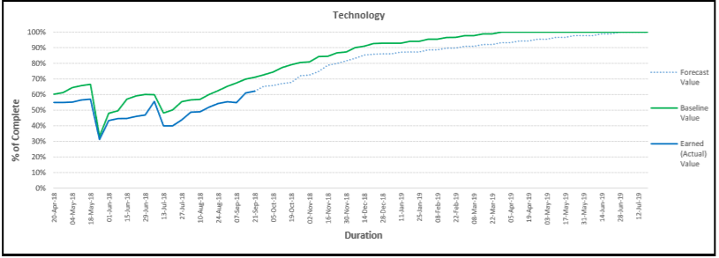  Key Achievements  - List the top achievement/s this reporting period
This Period | G | LG | LA | A | LR (-0.0%) | R | LG | G | G | G
Last Period
Include here a brief overview commentary on any movement in the ratings above.
- Explain briefly any movement in the keys (why a key has moved for example from Green to Light Green)
- Keys that are in exception (worse than LA) should be supported by brief comment/note on the go-to-green plan/s
- Refer to any related risks and/or issues you may have under management (reference JIRA #) – link through to any escalations / required decisions below.>>

Escalations and Required Decisions
- List any escalations, special notes and or decisions relevant for this reporting period
- List the (incl. JIRA # is available) risks, issues, etc you may wish to escalate (top 3 to 4)

The information on this page should be able to stand alone at the programme level, detailed pages to follow provide initiative / outcome level detail for operational level reporting

PS | CS | FT | Knowledge Transfer Status (People Intellectual Property)
G | LA | A
Brief status commentary (with progress compete shown in the harvey ball – show progress in 25% increments – go: Insert >Icons > search > Harvey Balls)

Key Milestones, Deliverables, Activities | Start | Finish | Current Status | Comment on reasons and go to green plans if not Green
<<Key Milestone or activity>> | dd/mm/yy | dd/mm/yy | LG | <<reason for not being green and go to green plans>>
<<Key event>> | dd/mm/yy | dd/mm/yy | G
<<key deliverable>> | dd/mm/yy | dd/mm/yy | LA

CONTRIBUTING TEAM STATUS
(Current delivery status of teams delivering services to the outcome.)
Team | RAG | Delivery Team Contact | Description of planned work/key activities | Comment if overall not Green/with plan to Green
ACCOUNT MANAGEMENT
PRODUCT OWNERSHIP
BUSINESS ARCHITECTURE
BUSINESS DESIGN
BUSINESS ANALYSIS
BUSINESS PROCESS DESIGN
START SOLUTION (incl. START reporting)
START DATA CONVERSION
DIGITAL ECO SYSTEMS (DES)
(Gateway services, Partner Integration)
DIGITAL CUSTOMER SERVICES (DCS)
(myIR, www, Content)
HERITAGE (incl. Contact Centre, Imaging)
ORGANISATION CHANGE MANAGEMENT & TRAINING (incl. Comms & Business Readiness)
TESTING SERVICES
RELEASE DEPLOYMENT
DATA CLEANSING AND ENRICHMENT
EARLY LIFE SUPPORT
PRODUCTION SUPPORT
(include if Prod Support are delivering changes)
ANALYTICS (DIP)
SECURITY
DECOMMISSIONING AND DATA ARCHIVING
ENVIRONMENT SERVICES
INFRASTRUCTURE (Networks, Software etc)
TECHNICAL ARCHITECTURE

Block plan template or OnePagerPro block plan
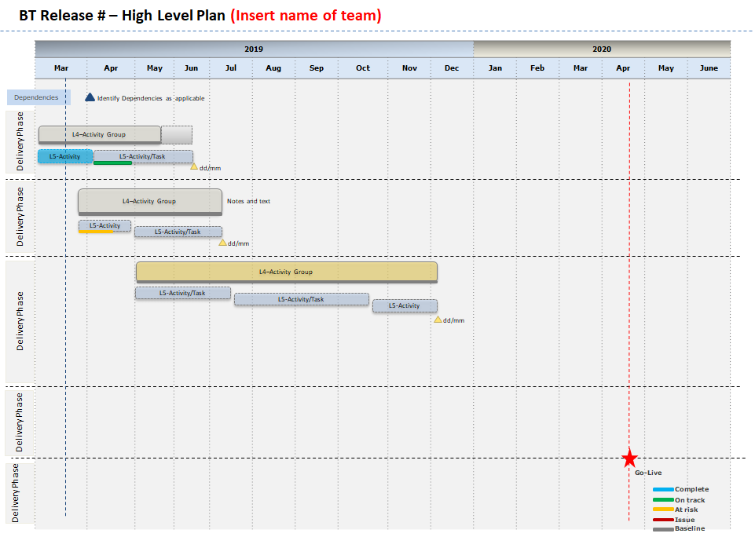
Example

Remove if not applicable

A further example of the type of timeline you might use on page 1 (remove if not used)

Provide a summary of the initiative finances if required (remove if not applicable)
Summary of Initiative Finances [$M]– mm/yyyy
Summary | Financial Year | Original Approved Budget | Escalations | Current Approved Budget | Budget to Date | Actual Cost to Date | Variance to Date | Estimate to Complete | Total Estimation at Completion | Forecast Cost Variance | Contingency
 |  | A | B | C=A+B | D | E | F=D-E | G | H=E+G | I=C-H | Departmental | Crown
Operating | 2018-19
 | 2019-20
 | Total Operating
Capital | 2018-19
 | 2019-20
 | Total Operating
Comments

